**Suna Jayyousi**

Traveltide rewards Program

# Introduction

E-booking startup TravelTide is a hot new player in the online travel industry. It has experienced steady growth since it was founded at the tail end of the covid pandemic (2021-04) on the strength of its data aggregation and search technology, which is best in class. Customer feedback has shown, and industry analysts agree, TravelTide customers have access to the largest travel inventory in the e-booking space.

# Objective

1. Splitting customers by choosing specific values for categorical variables.
2. Segment customer should be mapped to precisely one perk from reward program perks.

# Methodology

1. Sql code to understand the database and generate an aggregate table.
2. Tableau dashboards to segment users based on categorical methods.
3. Jupyternotebook to segment customer based on elbow method and clusters.

# 

# Findings

1. Based on our analysis we segment customers for each perk as shown below:

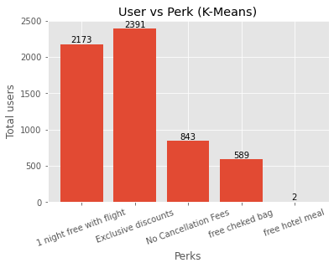

2-As shown in tableau dashboard below

Total cancellation: most of users have no cancellation history

Total flights booked: highest number of users have book a flight more than 2 time

Total hotel booked: highest number of users have book a hotel more than 3 time

Total checked bags: highest number of users have a 2 checked bag.

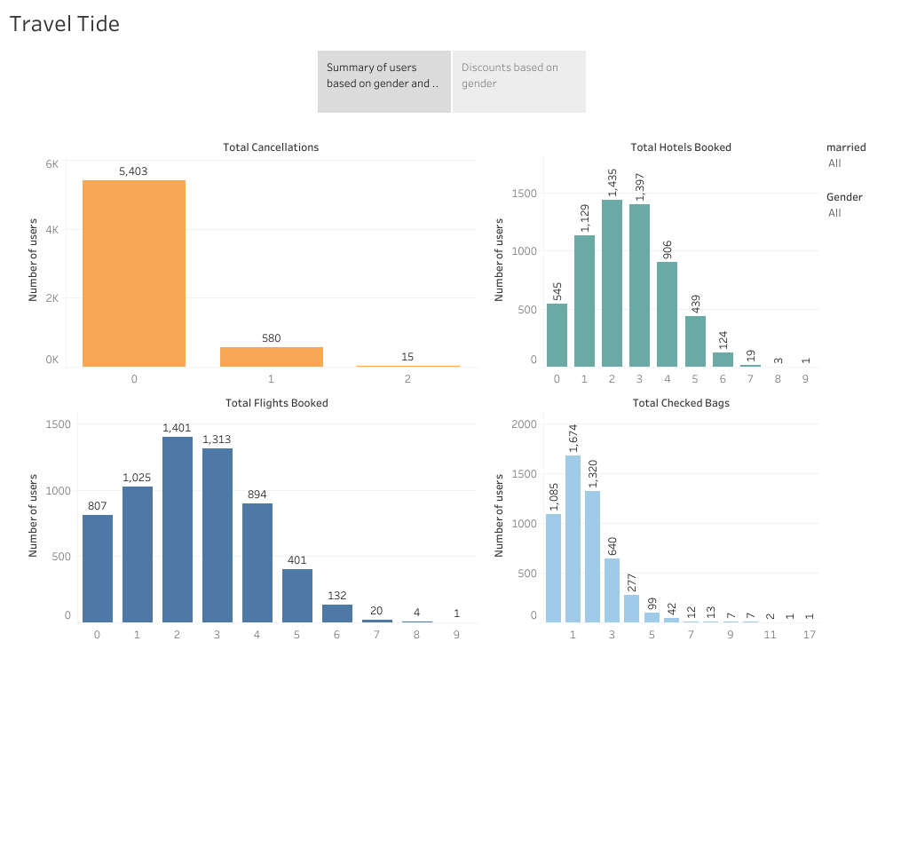

# Recommendations

1-We encourage the marketing department to launch the reward program.

2-focus on exclusive discounts perk.